
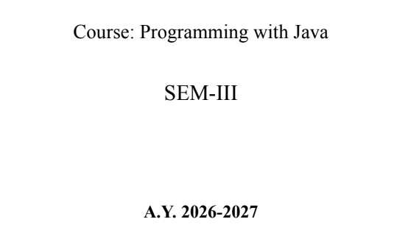
NAME: BHOOMI VIJAYVARGIYA
BATCH: A2
PRN: 25070122062
ASSIGNMENT-5
TITLE : Develop a Java application demonstrating the use of ArrayList, Vector, and StringBuffer for dynamic data storage, management, and string manipulation.
Problem Statement: Develop a Java application demonstrating the use of ArrayList, Vector, and StringBuffer for dynamic data storage, management, and string manipulation.
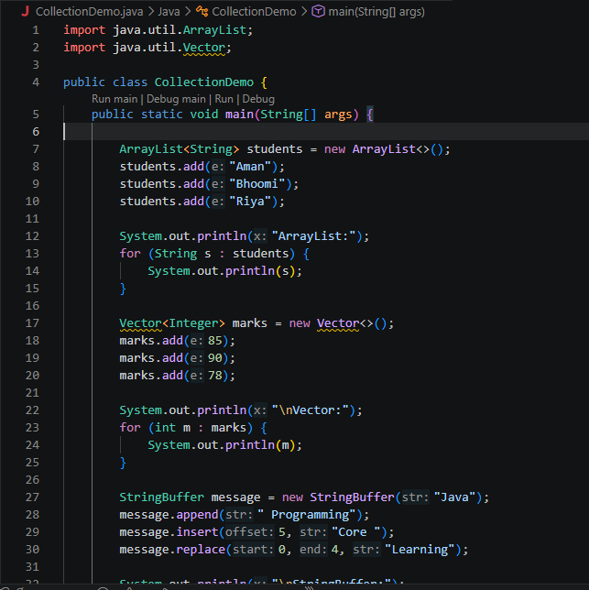
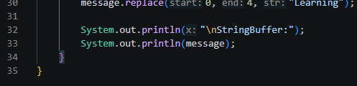
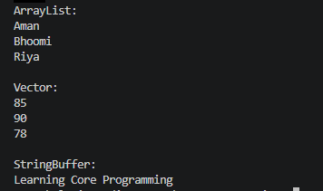
Learning Objectives: To implement dynamic data storage and string manipulation using ArrayList, Vector, and StringBuffer.

Theory
ArrayList and Vector are dynamic array implementations provided by the Java Collections Framework. ArrayList offers faster performance in single-threaded applications, whereas Vector provides synchronized operations for thread safety. StringBuffer is a mutable sequence of characters that allows efficient string modification without creating new objects. These classes are commonly used in applications requiring dynamic memory allocation and efficient string processing.
Outcome
• Successfully developed a Student Course Registration System using ArrayList to store and manage registered courses dynamically.
• Implemented functionalities to add, remove, and view registered courses.
• Used StringBuffer to efficiently generate and display the formatted list of registered courses.
Conclusion
- The application demonstrates the effective use of ArrayList for dynamic data storage and StringBuffer for efficient string manipulation.
- It provides a simple and user-friendly way to manage course registrations while reinforcing the concepts of Java Collections, string handling, loops, and menu-driven programming.

Exercise
- Create a To-Do List application using ArrayList to store tasks and StringBuffer to display tasks.
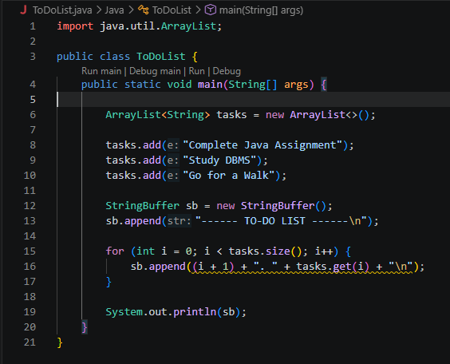
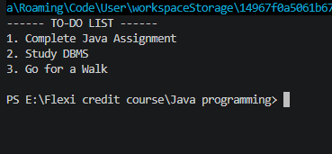
- Create a Student Course Registration System using ArrayList to store the list of courses registered by a student and StringBuffer to generate and display the registered course list. The application should allow users to add, remove, and view registered courses.
